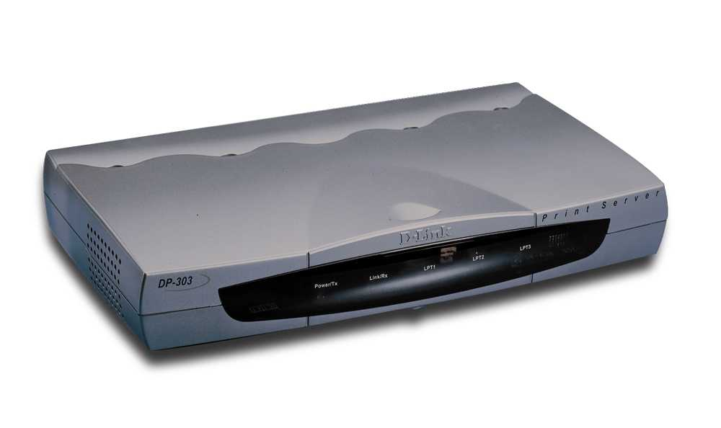
DP-303
10/100Mbps Print Server

Introduction
The multi-protocol print server makes network connection easy through the use of a NWay connection which allows the print server to be used with either Ethernet or Fast Ethernet LAN. The multi-protocol print server is equipped with high-speed parallel port , and a NWay port, transmitting at either 10Mbps. This allows the print server to auto-sense the best connection speed to use on the network without the need for end-user configuration .

Supporting IP, IPX, NetBEUI and Apple EtherTalk protocols , along with Ethernet, or Fast Ethernet , this print server is ideal for shared printing in mixed-LAN environments

The parallel port supports HP PJL protocol for bi-directional network printer communication. This feature allows the print server to collect information about the status of the printer while printing .

User Friendly
A user-friendly configuration program that works with Windows 3.x, Windows 95 , Windows 98, and Windows NT makes it possible to set up the print server in minutes.
Telnet support allows an administrator to remotely configure and maintain the print server on the Internet or a UNIX network

Large spool buffer let the print server safely handle multiple print requests. The print server provides outstanding performance over PC-based print server and PC parallel/serial connections. The print server’s compact size makes it possible to place it next to the printer , and allows more choices for printer placement on the network .

Specifications:
Printer port 3 IEEE 1284-compliant parallel ports
LAN port 1 auto-negotiating NWay RJ-45 port
Supported network protocols:
IP; IPX; NetBEUI; AppleTalk
Supported network O.S.:
NetWare 2.s and above (Native NDS)
HP-UX Unix, Sun O.S, Solaris, SCO
Unix, AIX, Unixware
Mac O.S. AppleTalk
LED Report Power/Tx, Link/Rx, LPT1, LPT2, LPT3
EMI FCC class A ; CE class A
Safety UL, CSA, TUV

Product Key Features:
- Equipped with 3 parallel ports allows to share three printers to all users on
- LAN simultaneously
- Equipped One N-Way port allows to auto-sense the best connection speed
- to use on LAN
- Multiple protocol supported is ideal for shared printing in mixed-LAN environments
- Bi-directional communication allows to collect information about attached
- printer’s status
- Windows-Based administrative program makes it possible to set up in few minutes
- Latest MIB-II (RFC 1213) for SNMP standard management
- Offer LPR program for Windows 95 TCP/IP printing
- Supports up to 36 Novell NetWare file servers
- Flash memory for easy software upgrade

Contents of Package
- One DP-303 print server
- One AC power adapter suitable for your country’s electric power
- Two PS Admin software diskettes
- One PS Admin User’s Guide
- One lpr software diskette
- One lpr User’s Guide

Ordering Information:
Print Server
DP-303 | 3 Parallel Port Multi-Protocol Pint Server

